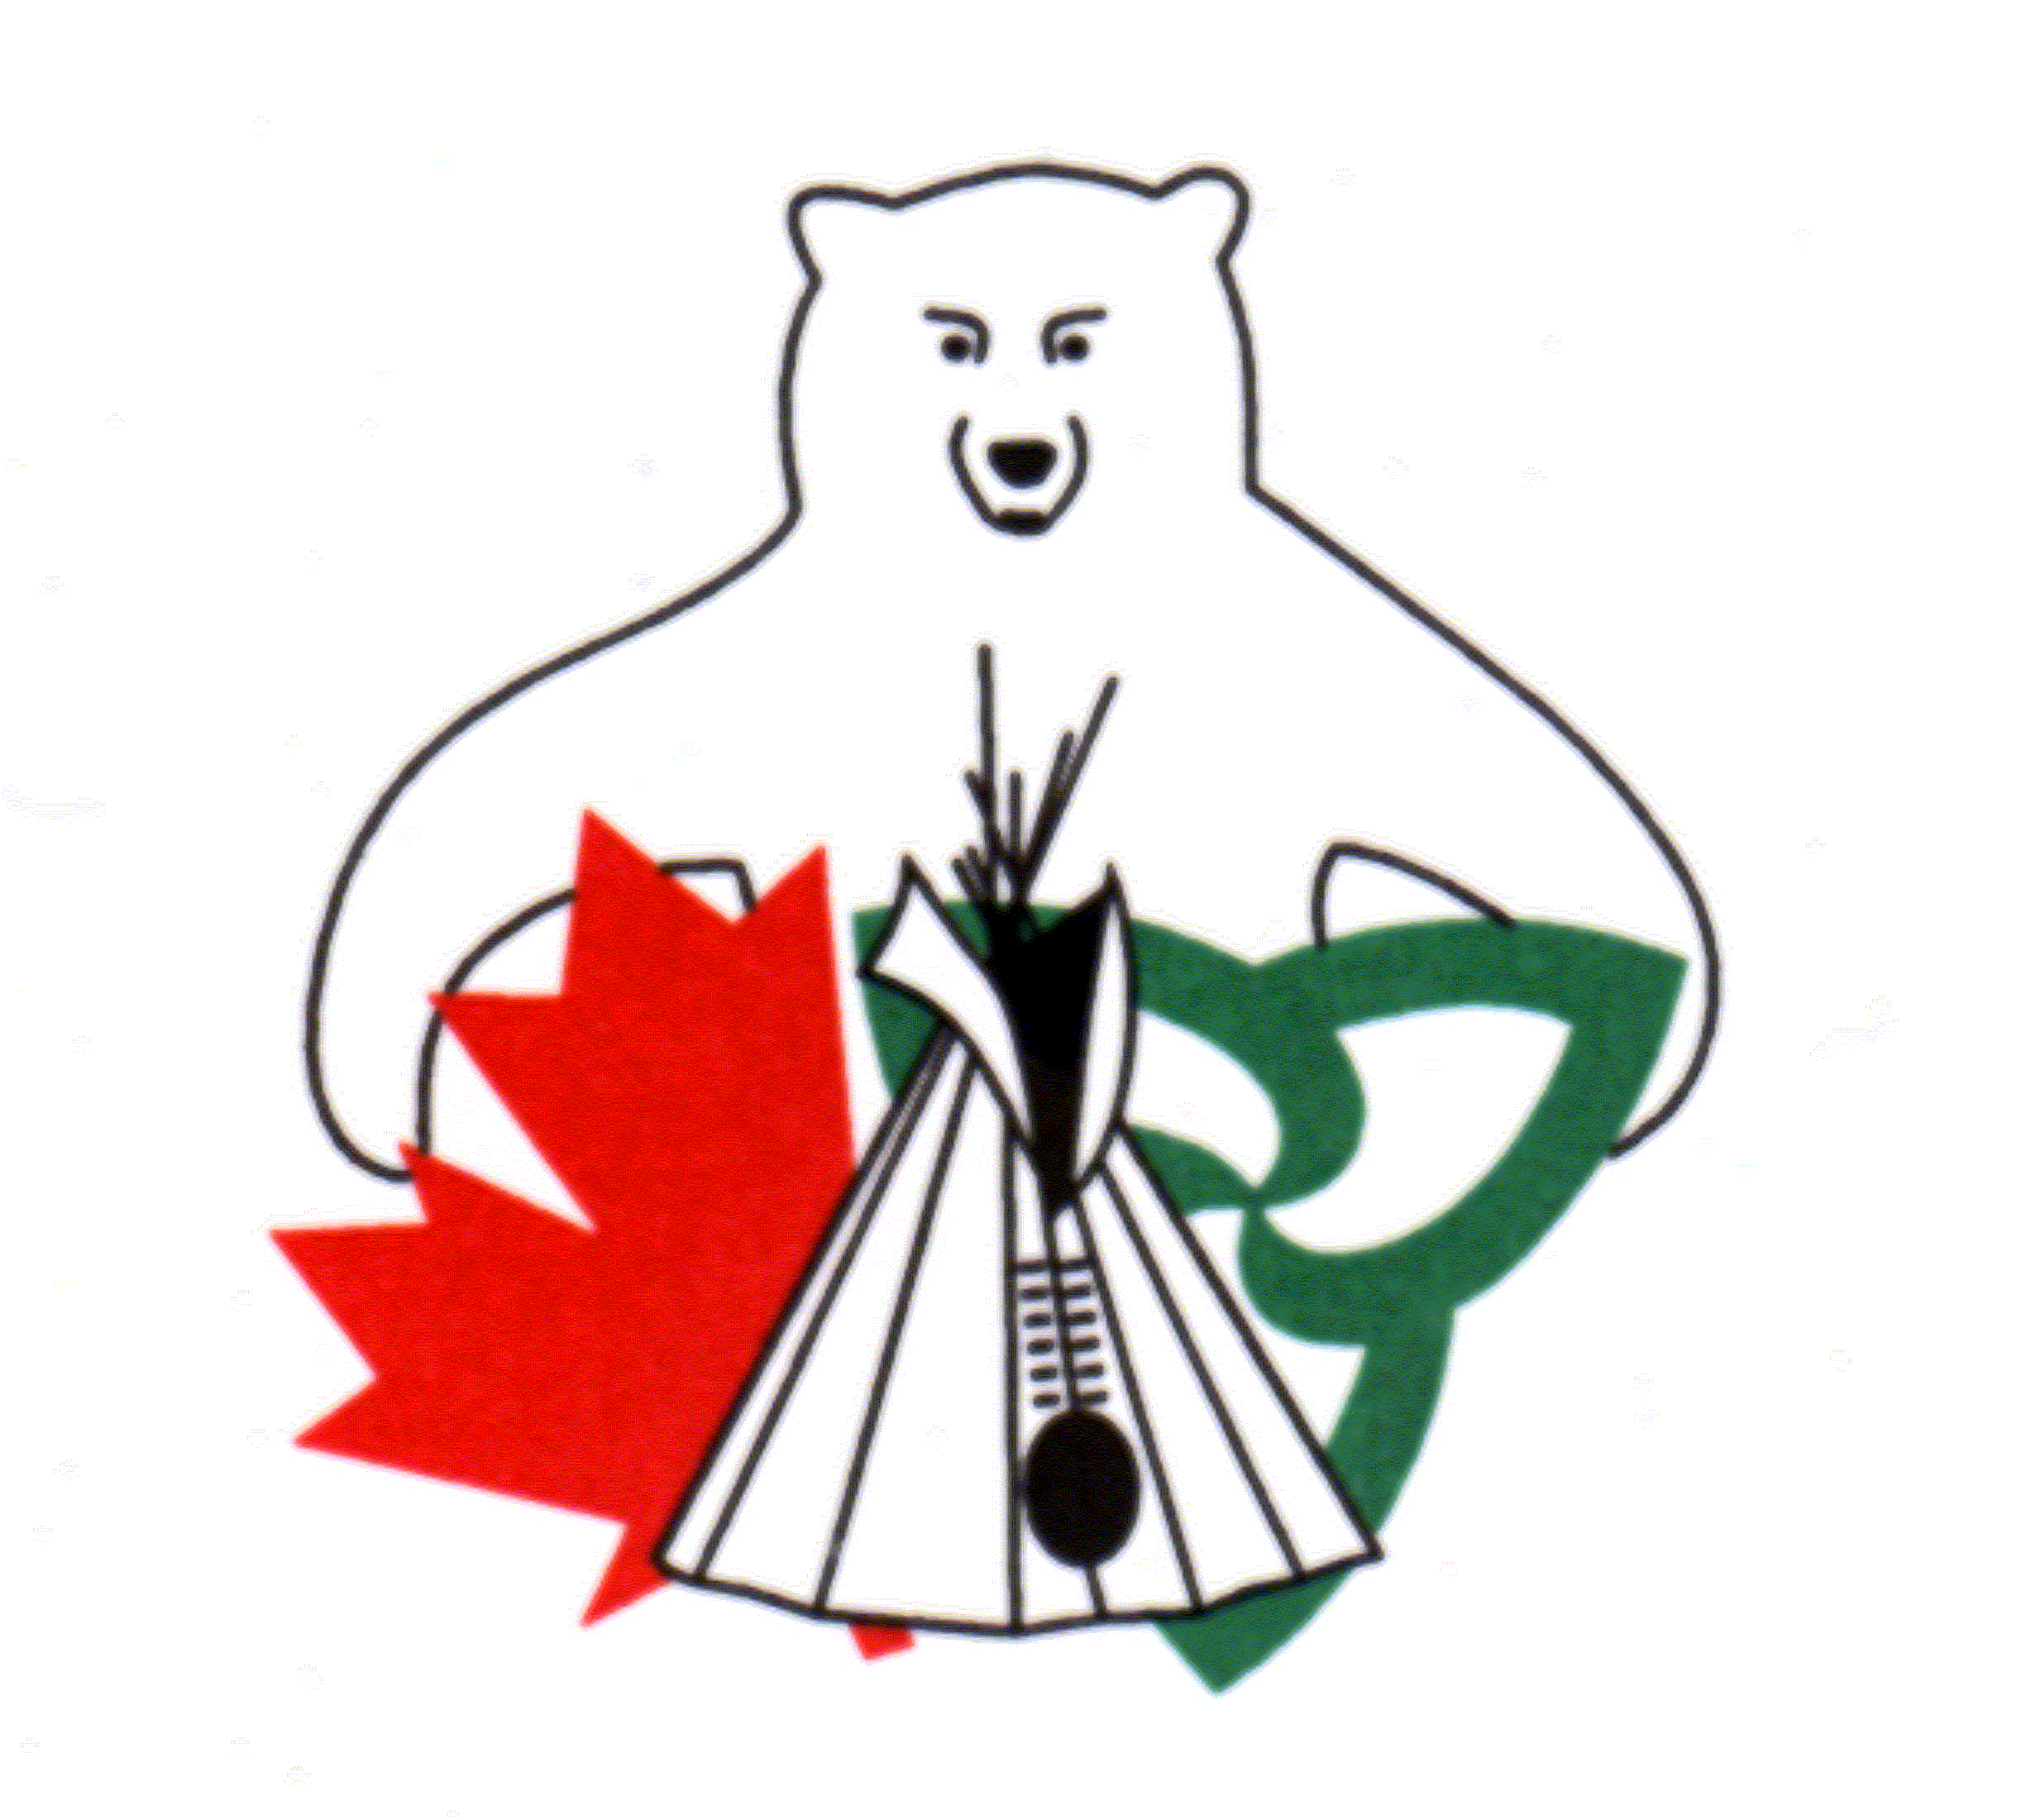
Canada Ontario Resource Development Agreement (CORDA)

2020-2021 Application

How to Apply:
The application form, in its original form, must be typed, completed in full and signed. Collect and attach all required supporting documents and any supplementary supporting documents. All supporting documentation must be included at the time of submission.

Using the Form:
Click on “Click or tap here to enter text” to complete each section. If you require more space in any area, simply keep typing and the form should expand accordingly. Alternatively, you may attach separate pages with additional information.

To use the check boxes, click on the box you want to check.

Once the Form is Complete:
Complete application packages must be sent to the CORDA Office by either e-mail, fax or regular mail. Only one copy of the application package is required. Applicants are encouraged to send an electronic application package to corda@nexicom.net. If sending by e-mail, please ensure the total file size of attachment(s) is less than 10MB as larger files may not be delivered. You may send multiple e-mails if required to ensure all attachments are submitted.

Please do not attach this cover information sheet when submitting your application.

Deadline to Apply:
Applications must be received by the CORDA Office by 4:00 p.m. Eastern Standard Time Monday, November 18, 2019.

Additional Information:
Funding for 2020-21 and beyond is subject to confirmation of funding. Applications will be received and reviewed in anticipation of funding availability. Final approval of projects will be based on the confirmation of funding.

Incomplete, unsigned or late applications will not be considered. Submission of an application does not guarantee approval for funding.

Applicants will be notified in writing once funding decisions have been finalized.

CORDA Office Contact Information:
Jill Stevens, Secretariat
CORDA Office
123 Paudash Street
Hiawatha, ON K9J 0E6
Telephone: 705-295-7116
Facsimile: 705-295-7144
E-mail: corda@nexicom.net
Internal Use Only: Project #: _______________ MNRF District: _________________________________

Canada Ontario Resource Development Agreement (CORDA)

2020-2021 Application Form

Part 1: Applicant Information
Name of Applicant (Individual, First Nation or Organization):
Click or tap here to enter text.
Name of First Nation of which the applicant is a member:
Click or tap here to enter text.
Please check which Treaty Organization the First Nation is a member of:
GCT#3 ☐ UOI ☐ NAN ☐ AIAI ☐ Independents ☐
Name of Contact Person (if different than applicant):
Click or tap here to enter text.
Position or Title of Contact Person:
Click or tap here to enter text.

Contact Information
Address (Street Number, Street Name, Unit #): Click or tap here to enter text.
P.O. Box: Click or tap here to enter text.
City/Town: Click or tap here to enter text.
Postal Code: Click or tap here to enter text.
Telephone Number: Click or tap here to enter text.
E-mail Address: Click or tap here to enter text.

Part 2: Project Details
Project Title: Please choose a title that explains the project. For example, “Updated Equipment for Commercial Fishing Enterprise”.
Click or tap here to enter text.

Project Objective. List the expected results in two or three sentences or bullets. For example, “The project will result in increased revenue or jobs,” or “The project will add value to the product”, or “The project will result in improved fishing with new nets and gear”.
Click or tap here to enter text.

Project Description. Provide a detailed description of the project, how the funding will be spent, how the project will be undertaken. Describe the major milestones (steps) and what will be accomplished. Include any photographs or diagrams that may support the project. Identify other agencies or groups that were consulted. You may attach additional pages if required.
Click or tap here to enter text.

Project Location.
Check whether the project activities will occur on or off First Nation reserve:
On First Nation reserve ☐
Off First Nation reserve ☐

Describe the location of the project activities. If the project is outside a First Nation community, please include a location map. An online mapping tool to make a map can be accessed at: http://www.gisapplication.lrc.gov.on.ca/mamnh/Index.html?site=MNR_NHLUPS_NaturalHeritage&viewer=NaturalHeritage&locale=en-US
Click or tap here to enter text.

Natural Resource Management. What natural resource is being managed? Describe how the project will contribute to the management of that natural resource both in the short and long term.
Click or tap here to enter text.

Project Duration. Please indicate the project start and completion date. Projects will only be reimbursed for costs incurred as of April 1, 2020 and must be complete no later than February 19, 2021.
Start Date: Click or tap here to enter text. Completion Date: Click or tap here to enter text.

Previous Applications. Has the applicant previously applied for, but not received, funding for this project? Yes ☐ No ☐

Previous Funding: Has the applicant received previous CORDA funding?
Yes ☐ No ☐
If yes, please list previously approved project, including project number or the year the funding was received.
Click or tap here to enter text.

Environmental Impact:
Some applications may be subject to a federal environmental screening process. Applicants who are subject to this environmental screening will be notified about the process.

Does the project have the potential for negative effects on air, water, soil, land, etc.? Yes ☐ No ☐

If yes, describe the action that will be taken to reduce environmental impacts. Environment and Climate Change Canada or the Ministry of the Environment Conservation and Parks may be a resource for information on assessing environmental impacts.
Click or tap here to enter text.

Does the project have the potential for positive effects on air, water, soil, land, etc.?
Yes ☐ No ☐

If yes, describe the positive impacts the project will have to the air, water, soil, land, etc.
Click or tap here to enter text.

Part 3: Project Benefits
Provide details on the short and long-term benefits of the project. Use additional pages if required.
Economic. Please provide details on the economic benefits.

Check if the funding will be used to assist a new business or an expanding business:
New Business ☐ Expanding Business ☐

Provide details on any jobs that will be created, including the duration of each position.
Click or tap here to enter text.

Describe how the project involves First Nation community procurement. For example, provide details on any supplies to be purchased locally.
Click or tap here to enter text.

Estimate how much revenue will be generated:
Not applicable: ☐
Short Term: $Click or tap here to enter text.
Long Term: $Click or tap here to enter text.

Cultural. Please provide details on the benefits related to Traditional Knowledge and cultural values.

Describe how the project will use and support traditional cultural knowledge/values.
Click or tap here to enter text.

Describe how the project results in the transfer of traditional cultural knowledge/values.
Click or tap here to enter text.

Describe how youth from the community will be involved.
Click or tap here to enter text.

Overall. Please provide details on the overall benefits.

Does the project include training? Yes ☐ No ☐
If yes, estimate the number of people to receive training because of this project: Click or tap here to enter text.

Describe the type of skills that will be learned and/or developed.
Click or tap here to enter text.

Estimate the number of project participants, including volunteers: Click or tap here to enter text.
Does the project support a community plan, such as an economic, land use, forestry, or other plan? Yes ☐ No ☐
If yes, name the plan and describe how the project supports the plan.
Click or tap here to enter text.

List the anticipated community benefits resulting from the project.
Click or tap here to enter text.

Identify partnerships that will result from this project, including partnerships with other First Nations, municipalities, conservation authorities or academic institutions.
Click or tap here to enter text.

Part 4: Project Costs / Budget
Project a detailed project budget. The estimates will be compared to supplier quotes submitted with the application. The maximum funding level for CORDA projects is $35,000.00.

Have you applied to other funding sources for this project: Yes ☐ No ☐
If yes, please provide details including the name of the funder and the amount requested and/or approved:
Click or tap here to enter text.

Budget Instructions: List each item with name, the number of items requested, and the cost of each item. Please attach a separate sheet if additional space is required.
Category | Details | CORDA Request ($) | Applicant Contribution ($) | Other Funding Sources ($) | Total ($)
Example | Portable Sawmill Trailer, Chainsaws Safety Equip. | 30,000.00  5,000.00 | 800.00  600.00 |  | 36,400.00
Equipment | Click or tap here to enter text. | Click or tap here to enter text. | Click or tap here to enter text. | Click or tap here to enter text. | Click or tap here to enter text.
Materials | Click or tap here to enter text. | Click or tap here to enter text. | Click or tap here to enter text. | Click or tap here to enter text. | Click or tap here to enter text.
Labour | Click or tap here to enter text. | Click or tap here to enter text. | Click or tap here to enter text. | Click or tap here to enter text. | Click or tap here to enter text.
Transportation | Click or tap here to enter text. | Click or tap here to enter text. | Click or tap here to enter text. | Click or tap here to enter text. | Click or tap here to enter text.
Other | Click or tap here to enter text. | Click or tap here to enter text. | Click or tap here to enter text. | Click or tap here to enter text. | Click or tap here to enter text.
 | Total CORDA Request | Click or tap here to enter text. |  | Project Grand Total | Click or tap here to enter text.

Part 5: Supporting Documents
All applications must include supporting documents to be considered complete. All supporting documentation must be provided when submitting the application form. Applications without required supporting documents will not be considered for approval. It is recommended applicants submit additional supporting documents, depending upon type of project.

Check the attachments included with the application:
Required for all Applications:
☐ Supplier Quotes for all proposed expenditures
☐ A demonstration of community support by either a letter from Chief, a member of Council or a senior staff member such as the Band Administrator, or a Band Council Resolution (BCR). Applicants cannot sign their own support letter. Applications from a First Nation must include a BCR
☐ A clear map(s) showing the specific location of the proposed activities
Recommended additional supporting documents:
☐ A letter of support from an appropriate administering agency such as the Ministry of Natural Resources and Forestry
☐ Photograph(s)
☐ Any permits or licenses required (such as commercial trapping or commercial fishing licenses)
Additional supporting documents such as a Community Economic Development Plan, Feasibility Study, or Business Plan
☐ Other documents: Please specify: Click or tap here to enter text.

Use of Personal Information
Personal information on this form is obtained under the authority of Section 13.1 (1) of the Ministry of Natural Resources Act, Section 8, R.S.O. 1978. The information submitted in this application is to assess the applicant’s request for funds under the CORDA program. The financial and technical information will be used to determine eligibility of the application to have a program designated, for financial assistance and the amount of such assistance, for audit purposes and for project summary review. Questions or concerns regarding use of personal information should be directed to Chair, Canada Ontario Resource Development Agreement, c/o Ministry of Natural Resources and Forestry, Integration Branch, 300 Water Street, 5th Floor, South Tower, Peterborough, ON K9J 8M5 or by phone at (705) 755-5274.

☐ I consent to the publishing of my name, funding and project description in the 2020-2021 CORDA Annual Report to be distributed to government partners and the public.

Declaration
I declare that I am a First Nation member or an official of a First Nation organization or a Treaty organization in Ontario and that the information in this application for a Canada Ontario Resource Development Grant is true, correct and complete in every respect. I hereby authorize the CORDA Committee through his/her representatives to make such enquiries, undertaking such discussions and share such information with other public and private agencies with respect to my application as she/he may in his/her discretion deem necessary for the evaluation and assessment of the proposal.

Applicant Signature(s)

Name and Title

Date

